Hello!
Branch Hello!
Operating systems:
  - macOS 12.0 or later
  - Windows 10 64-bit or later. You must have a 64-bit operating system to run GitHub Desktop.
Storage space requirements:
  - The .exe file is ~200MB for windows, and ~415MB for MacOS systems.
- To begin the install process, you need to go to the GitHub download website here: https://desktop.github.com/download/ 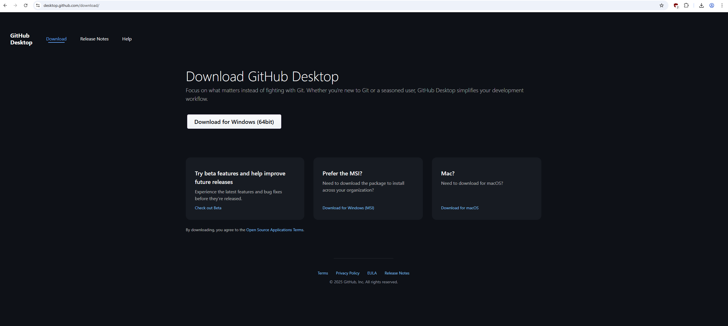
  - You then must click the Download For Windows (64Bit) button to download the .exe file for Windows operating systems. Once downloaded, you must navigate to the download location and double click the setup file to begin the installation process. Once the program is installed, it will open automatically.
  - If using a MacOS operating system, you must click on the Download for MacOS link. This will download a Zip file. Once unzipped, navigate to the GitHub Desktop Application file to begin the installation process. Once the program is installed, it will open automatically.
  - GitHub is currently not available for Linux devices.
- How to create an account on GitHub.com
  - If you have not created a GitHub account, follow the below steps:
  - Navigate to github.com webpage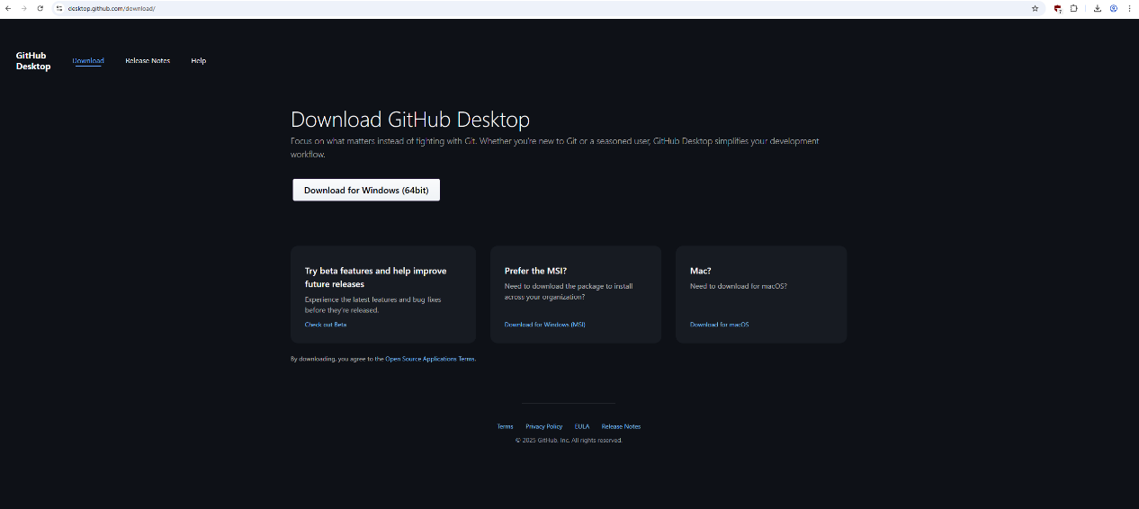
  - Click ‘Sign UP’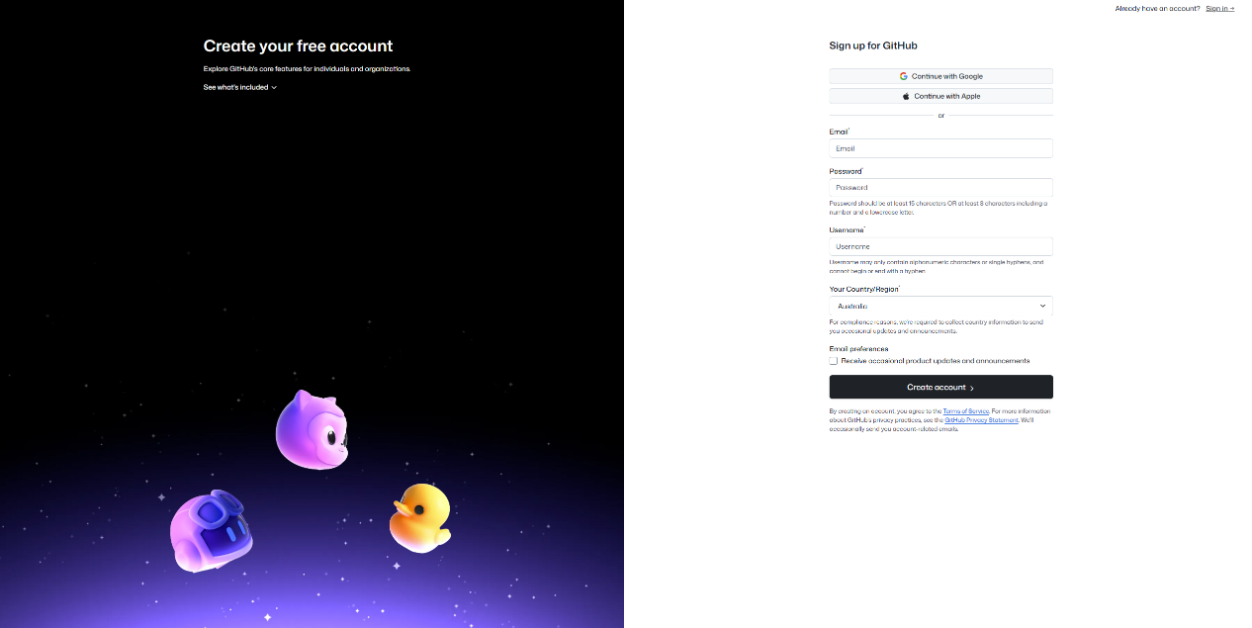
  - You can either choose to signup with an email address or sign up by linking a Google or Apple account
  - You must also pick a username and password
  - After this, you must verify your email to begin using the account.

- How to link GitHub.com to the installed Desktop app.
  - Now navigating back to the downloaded Desktop App, on launch you will be asked to log into your new Git account. To do this it will launch your internet browser and ask you to log in. Once logged in with your account details, you will be prompted to navigate back to the desktop app where the account will then sync with the desktop app.
- Who to commune with in the event of a failed installation.
  - In the case there are any issues with the installation process, GitHub has a support page: https://support.github.com/ or documentation: https://docs.github.com/en/desktop that can help with resolving installation issues.
  - If unresolved, you can submit a ticket request at https://support.github.com/request to work through resolving the installation issues.

